DOCKER LAB 3:

DOCKER VOLUMES

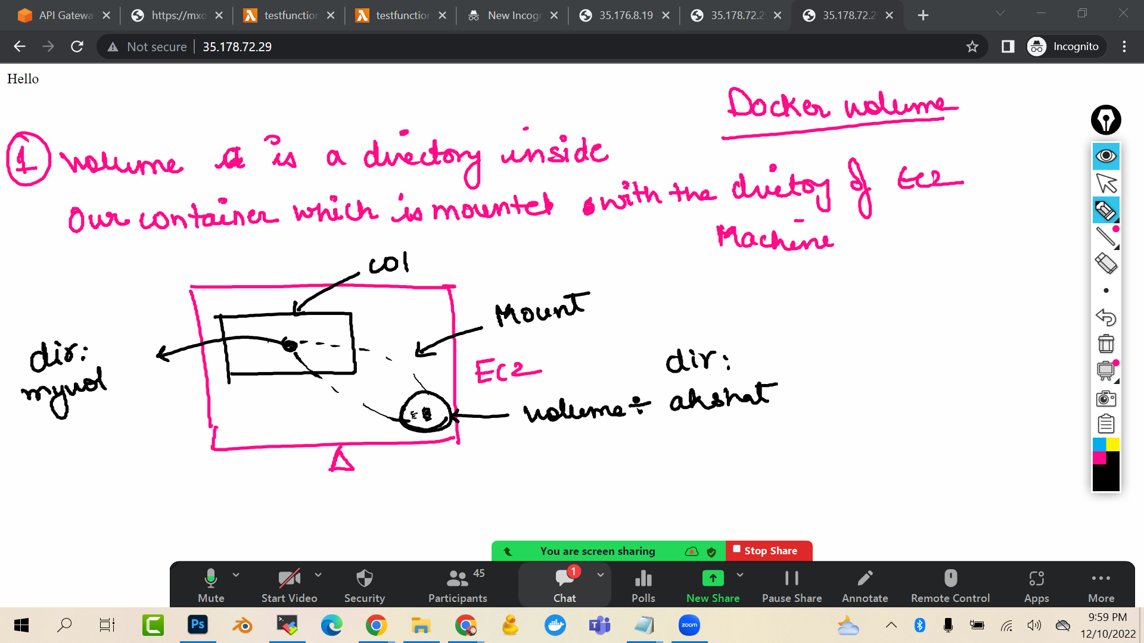

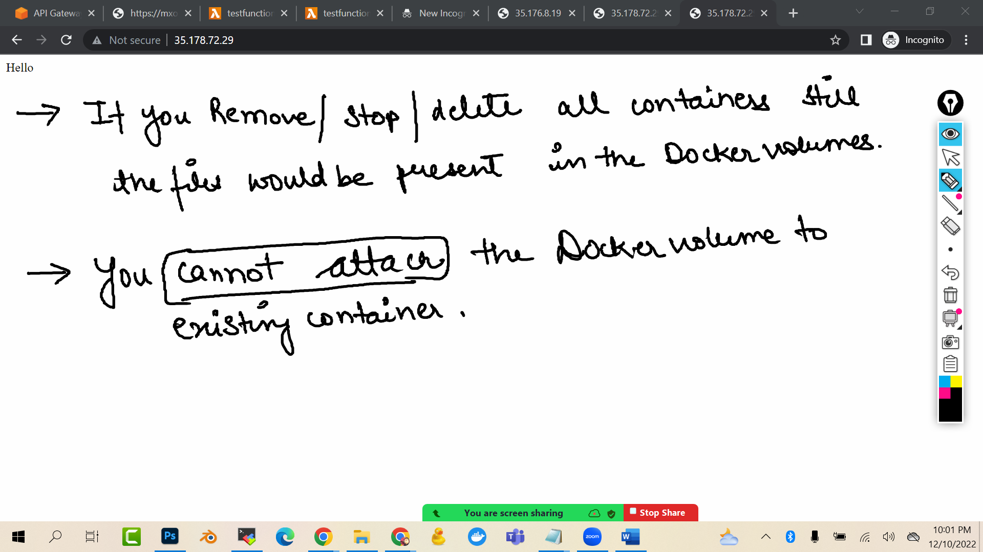

LAB:

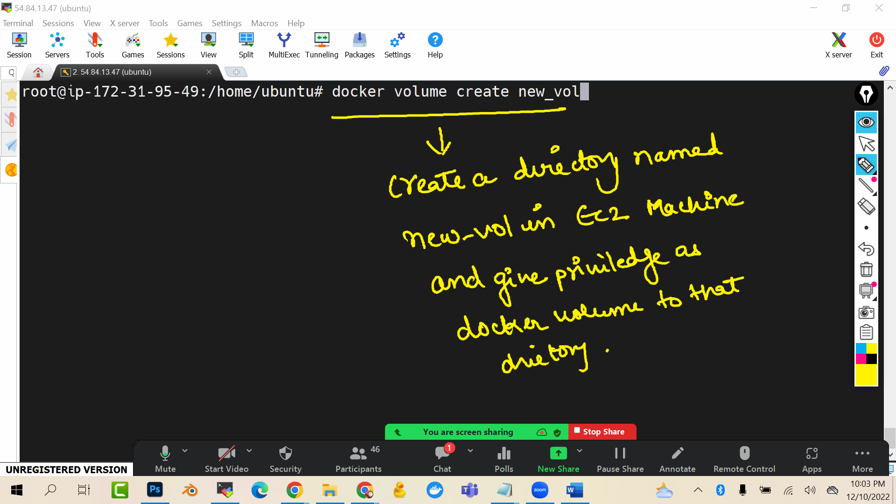docker volume create new_vol

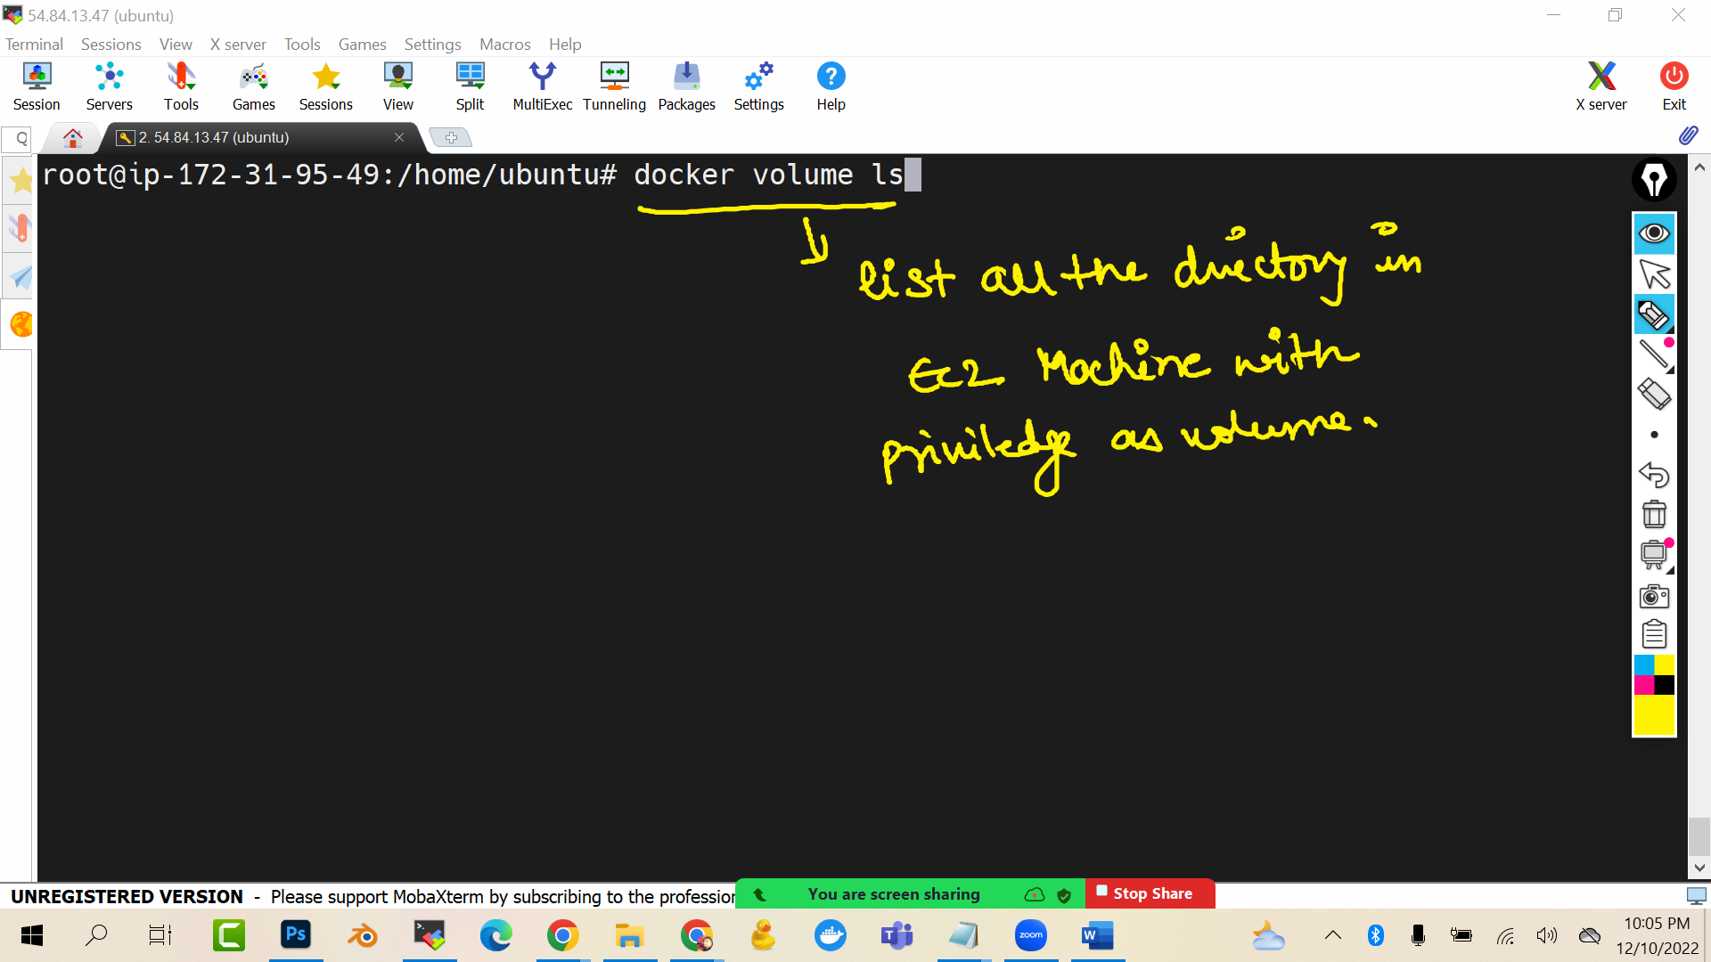

docker volume ls

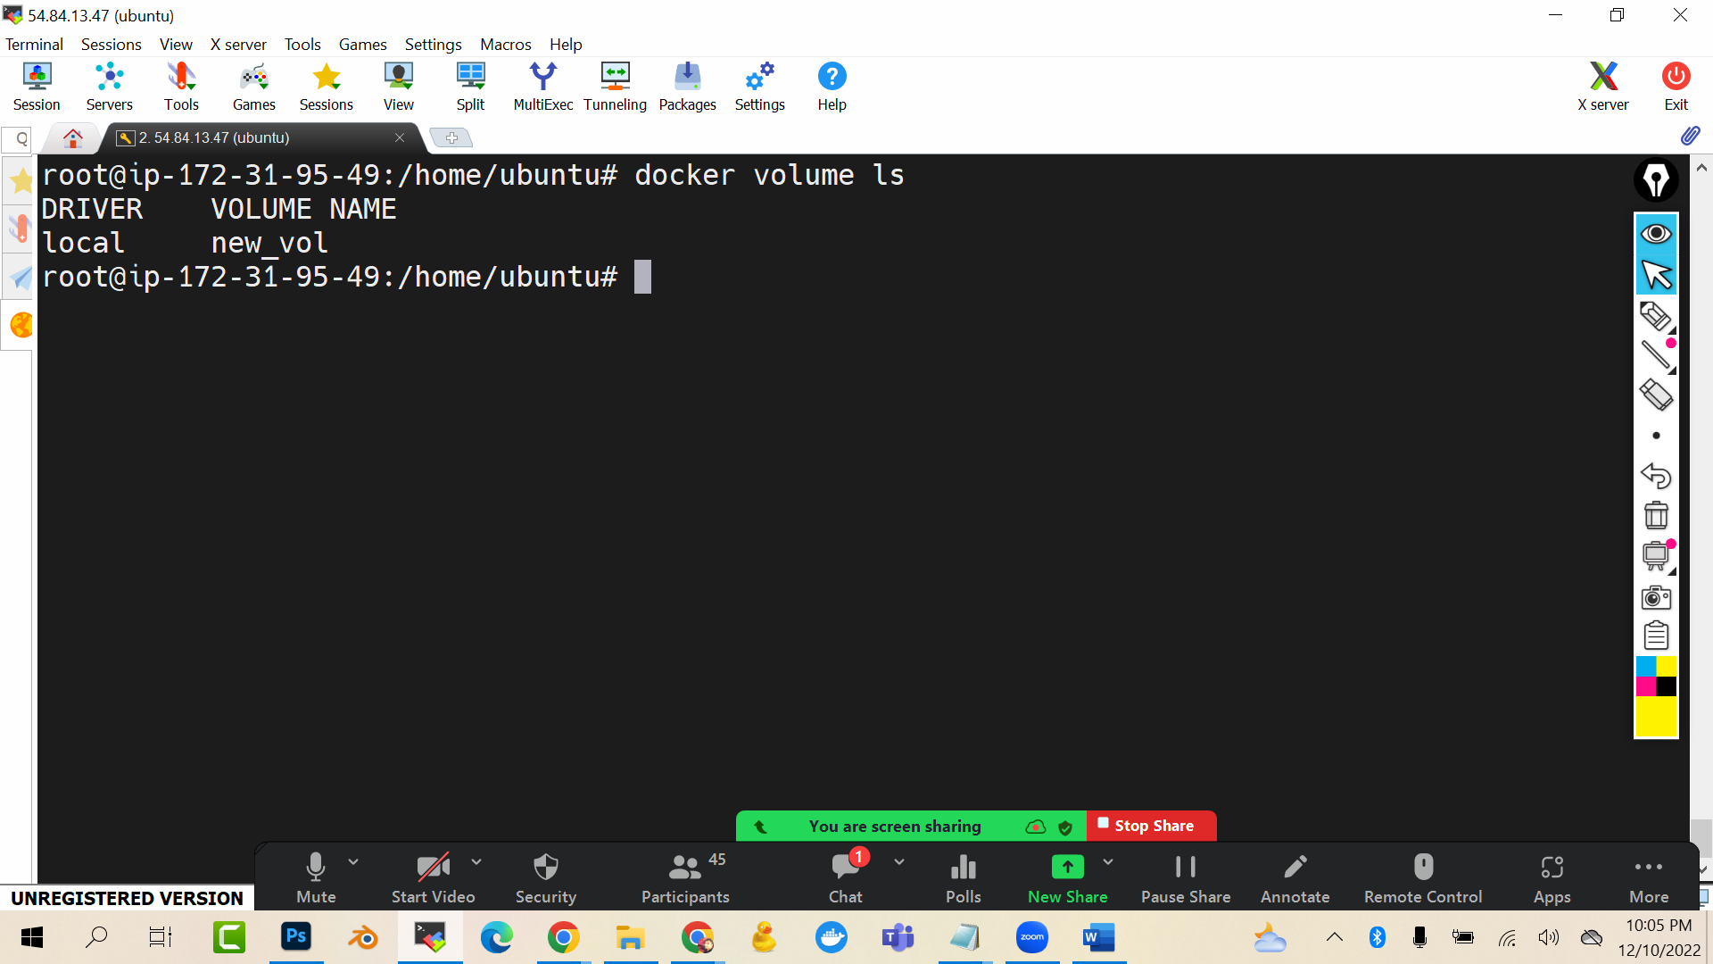

This is new_vol is created in the ec2 machine…now we will create a docker container and mount this new_vol with a directory of docker container. …

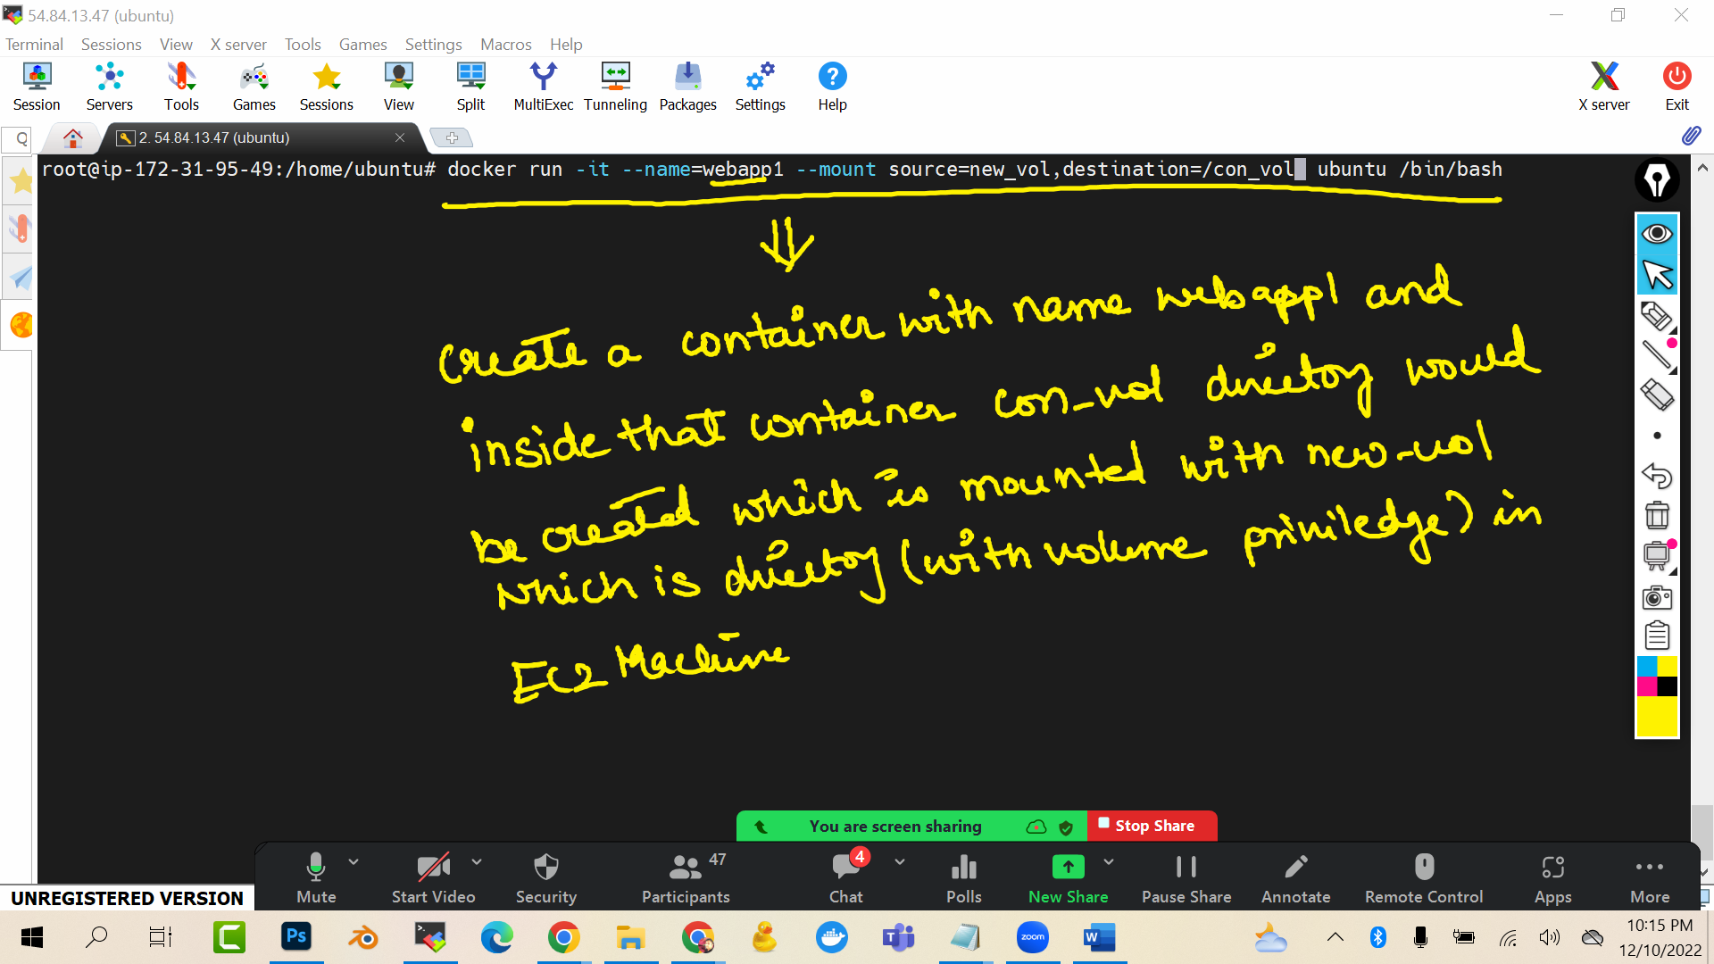

docker run -it --name=webapp1 --mount source=new_vol,destination=/con_vol ubuntu /bin/bash

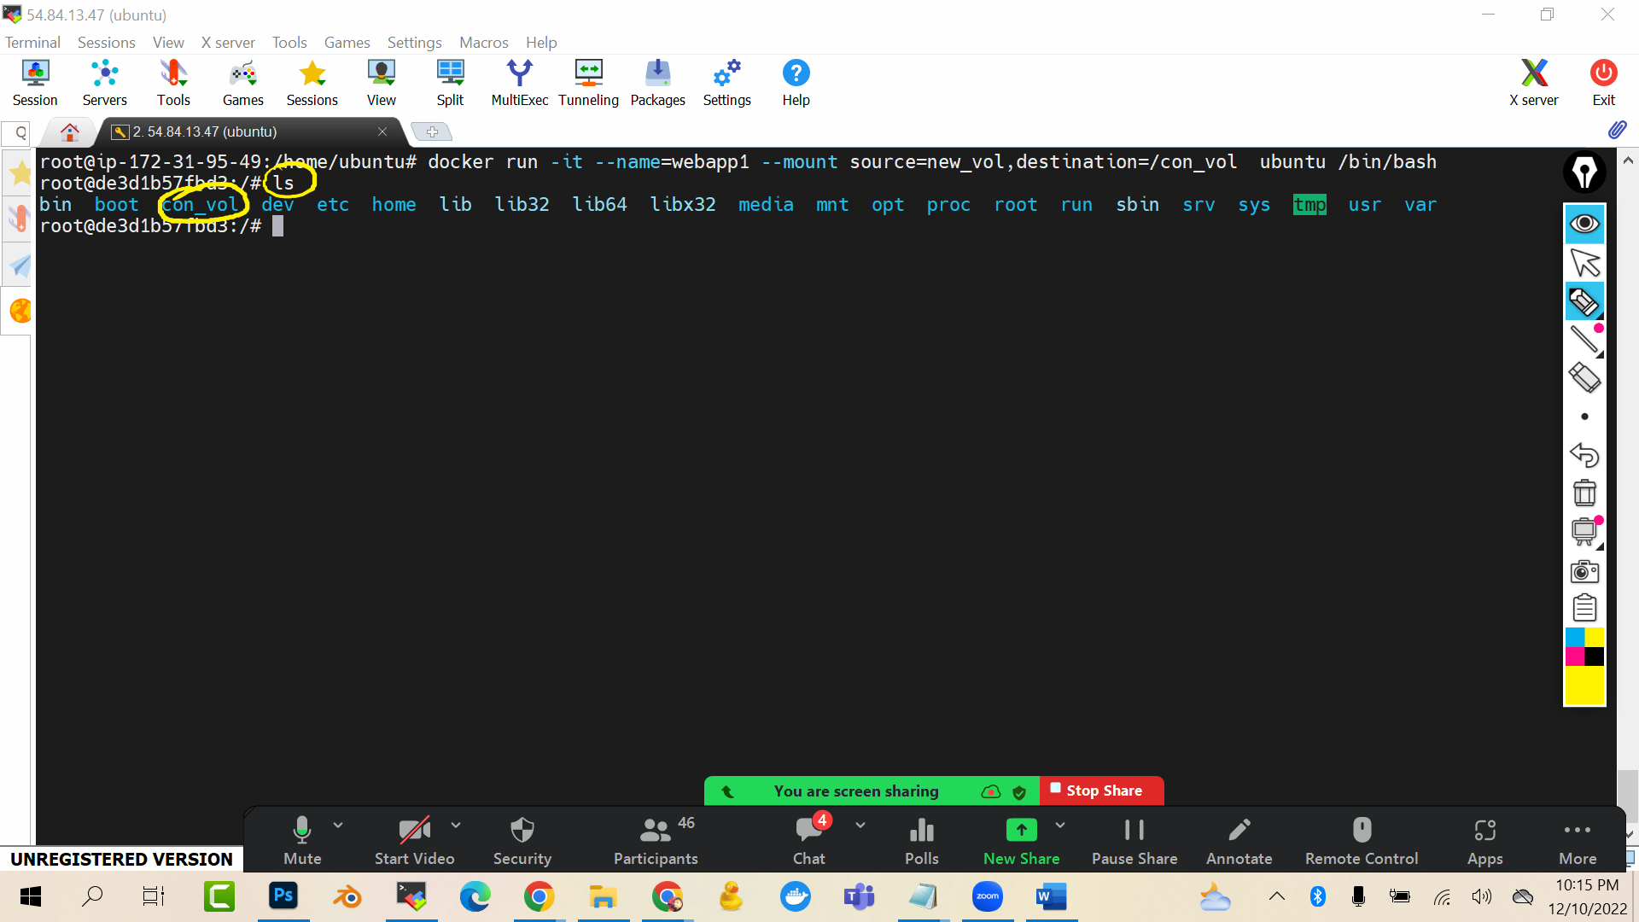

cd con_vol

touch file1 file2 fileakshat file3

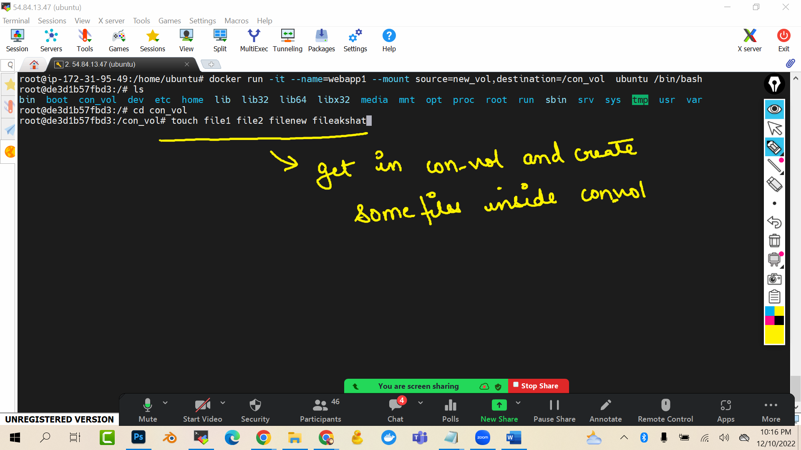

Simply now exit the container

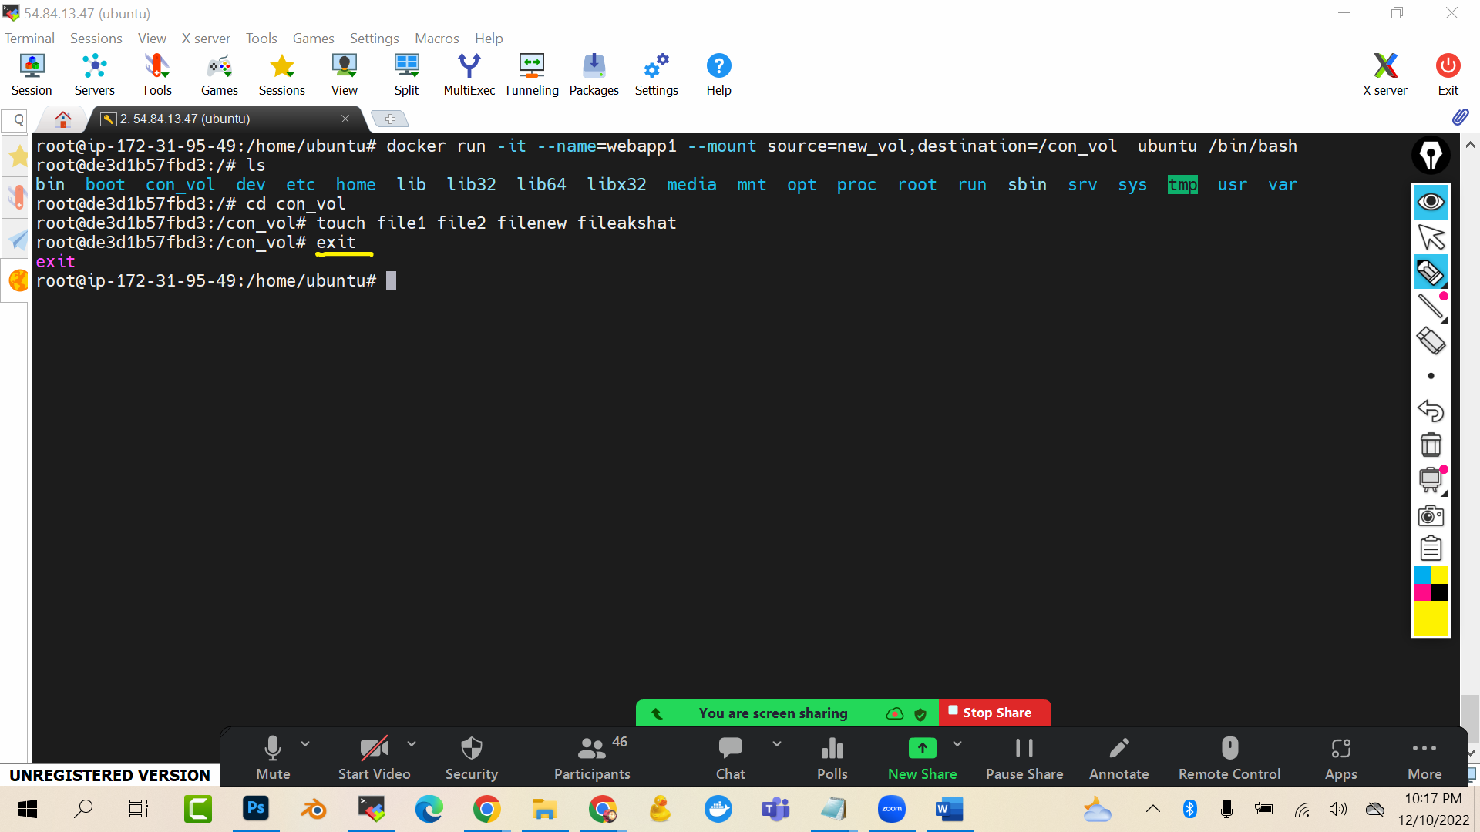

Now lets cross verify that these files which we have created in the con_vol is showing up in the new_vol of ec2 or not

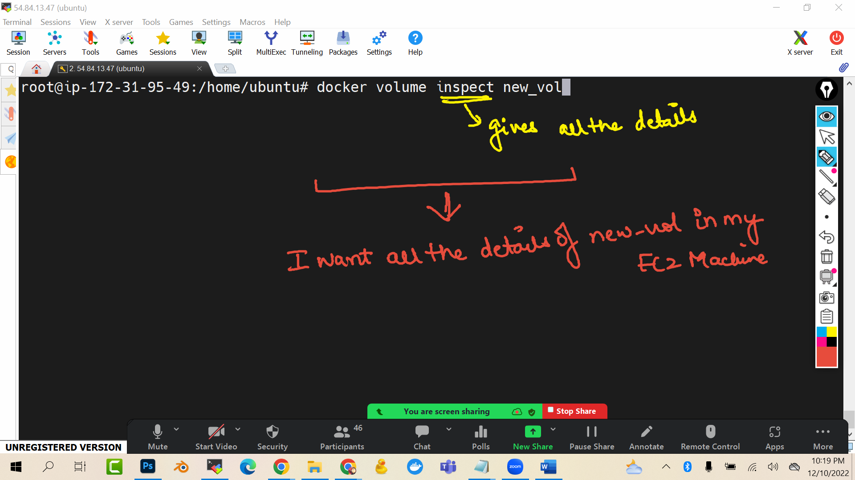

docker volume inspect new_vol

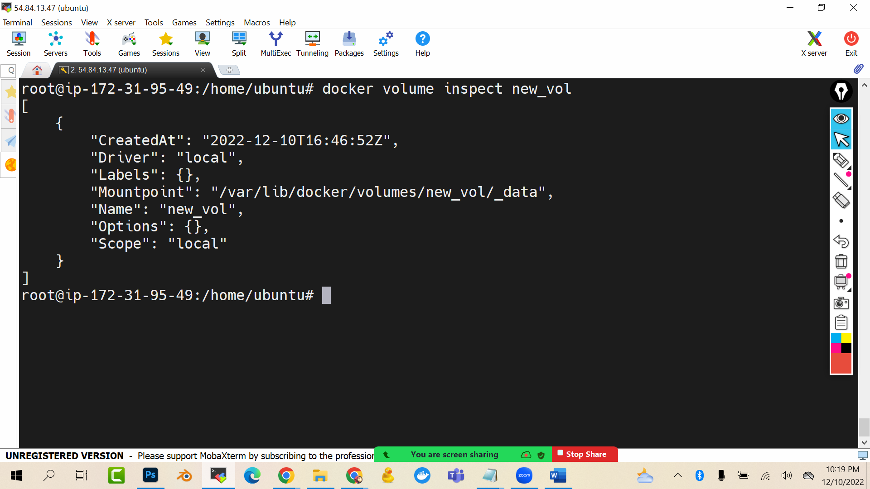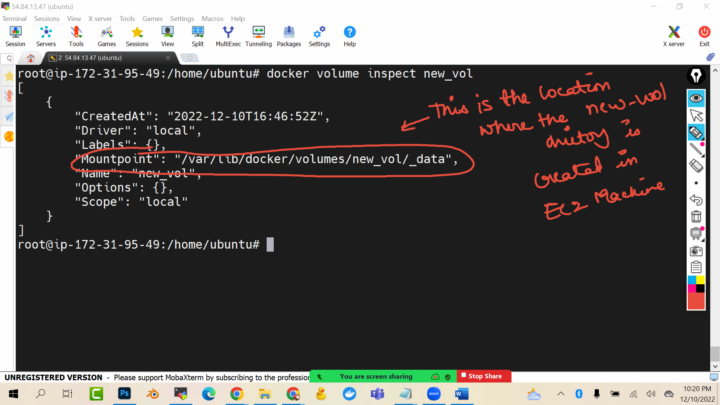

cd /var/lib/docker/volumes/new_vol/_data

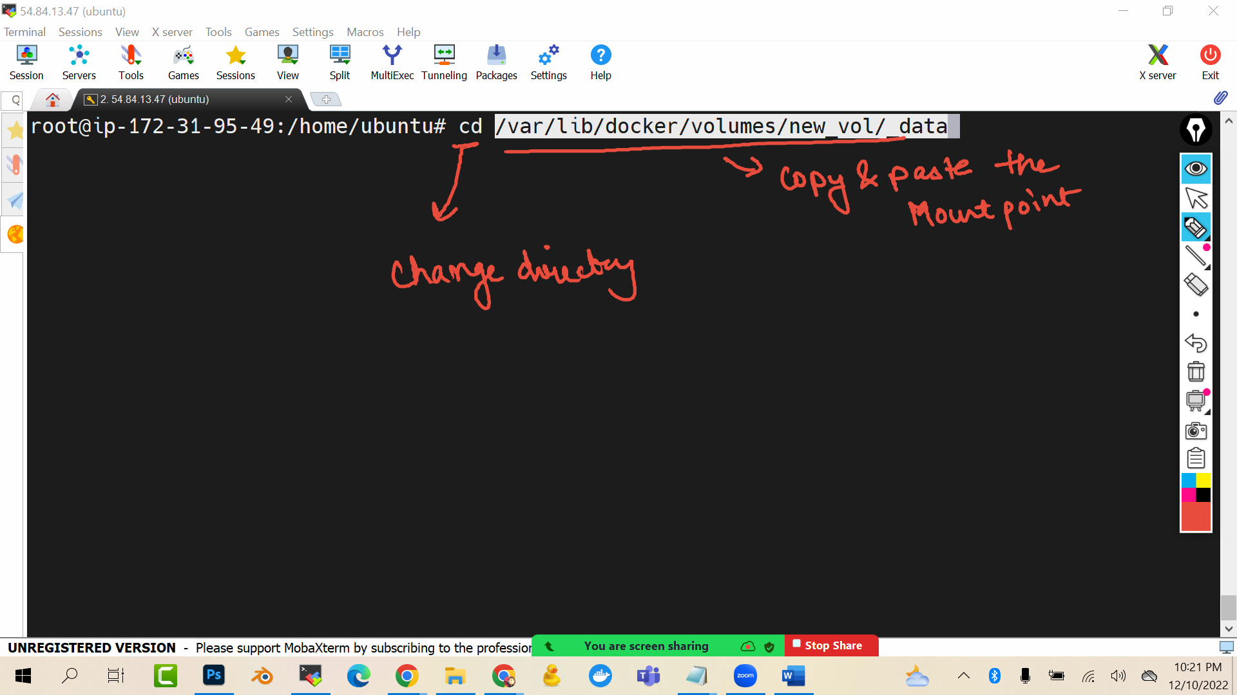

ls

you will see the files which you created in con_vol of container

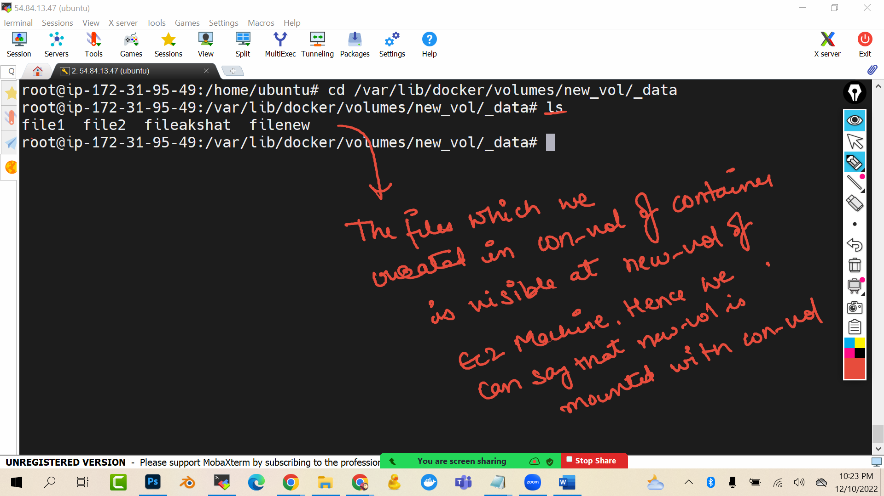

Lets create some files in new_vol of ec2 and verify If these files are visible in con_vol or not

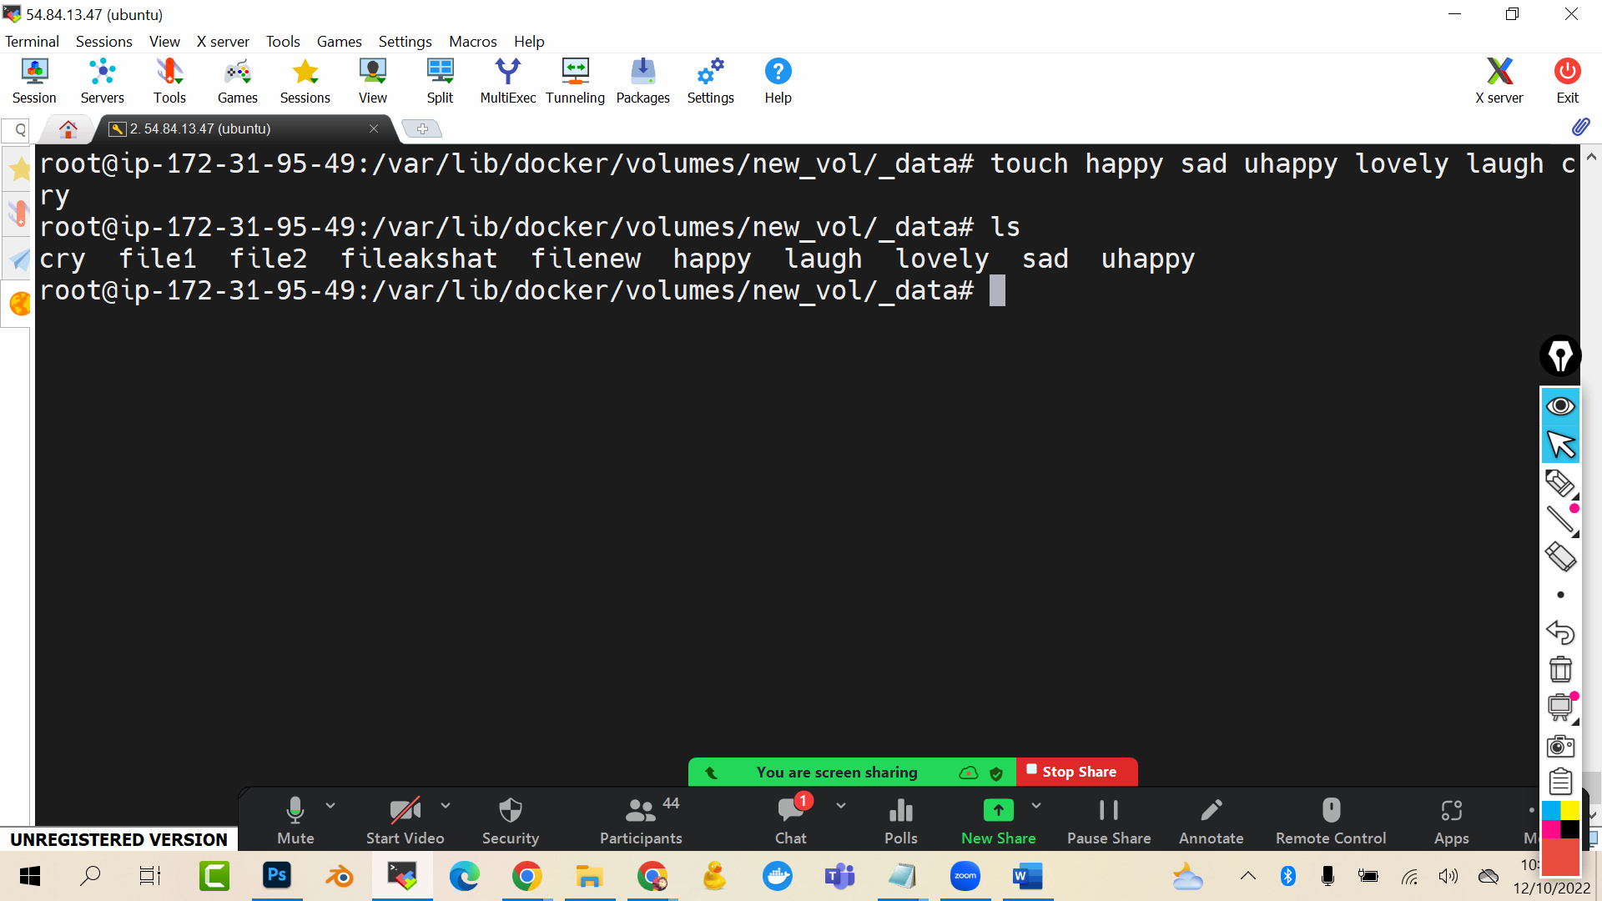

touch happy sad uhappy lovely laugh cry

ls

docker start webapp1

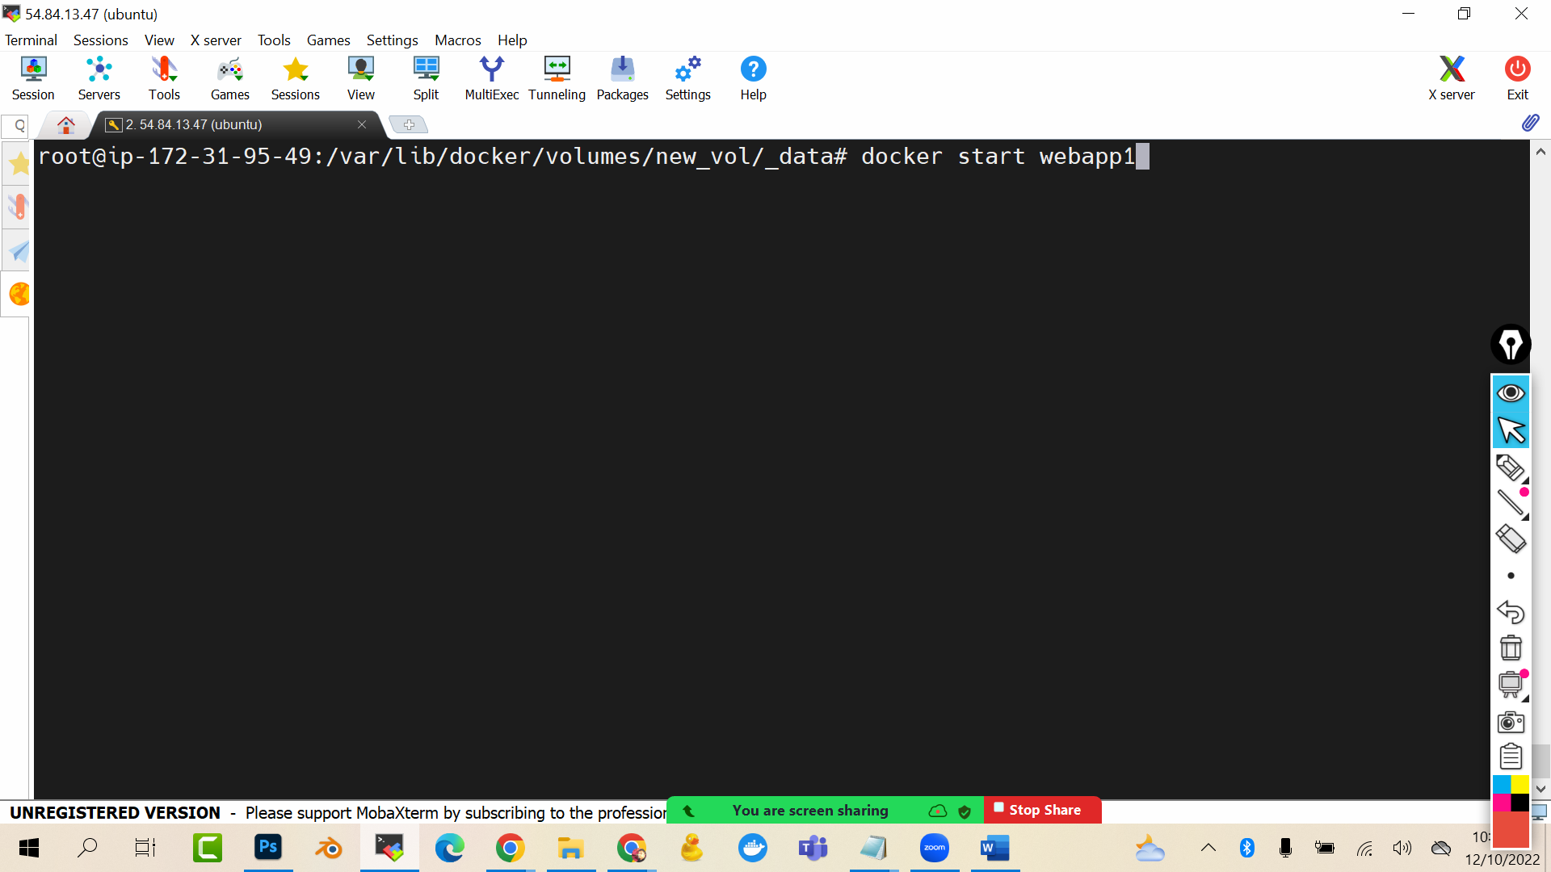

docker attach webapp1

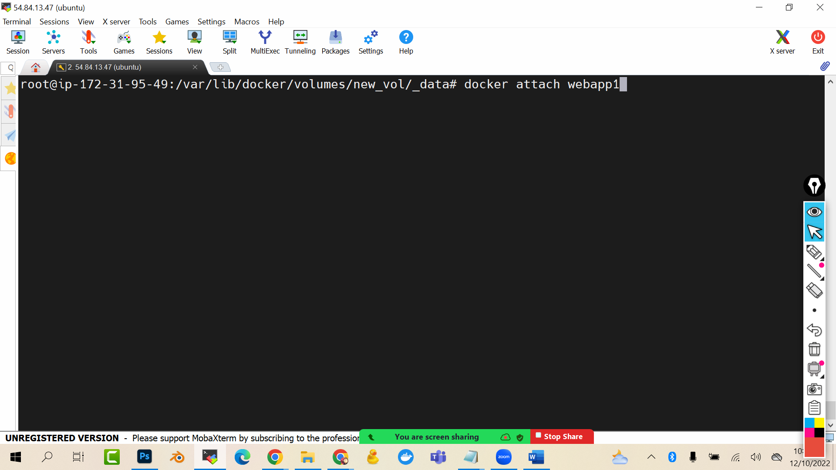

ls

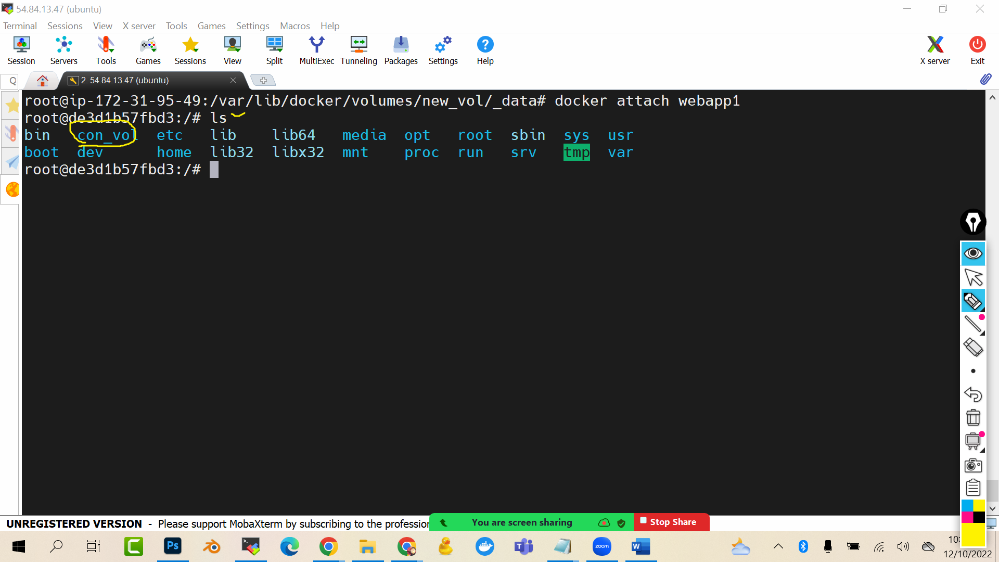

cd con_vol

ls

